**Lab 22 - Virtualization Type2 Hypervisor**

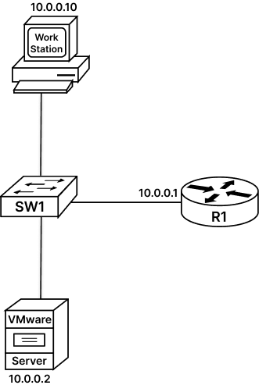

**Task 1: Creating Virtual machine on Type2 Hypervisor:**

**Step 1: Start VMware Workstation (Type 2 Hypervisor software) that is running on Ubuntu host OS.**

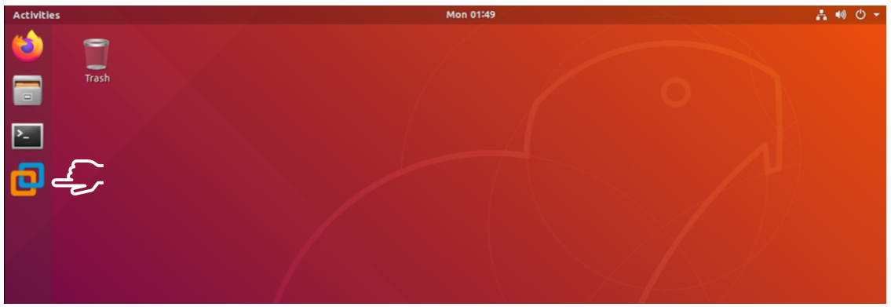

This will launch the VMware Workstation application as seen below

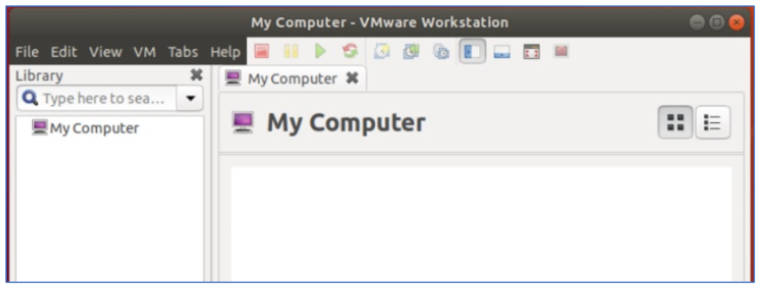

**Step 2: Go to File Menu of VMware Workstation and click New Virtual Machine.**

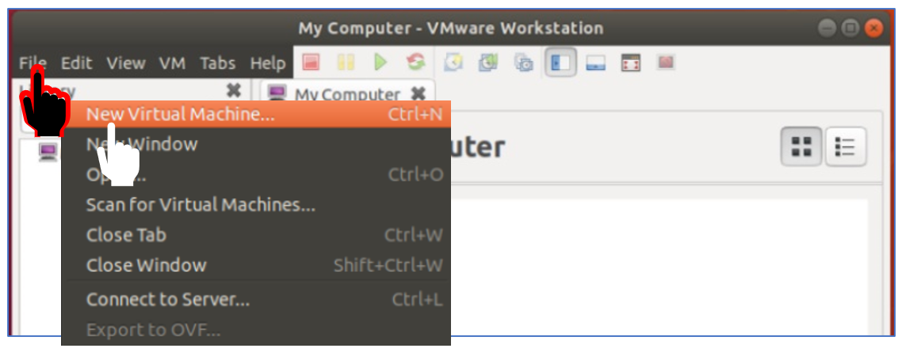

As seen below, this will open a new window that will help us create new Virtual Machine.

**Step 3: Select Typical VM configuration option and press next. This will help us create VM with fewer simpler steps.**

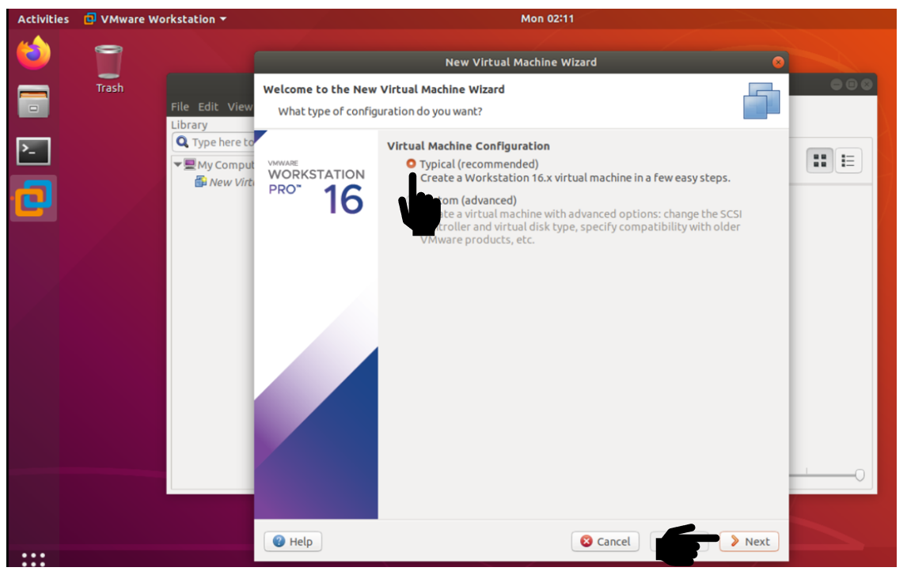Following screen will be displayed, now select option to install Operating system later

**Step 4: Select option to install Operating system later and press next.**

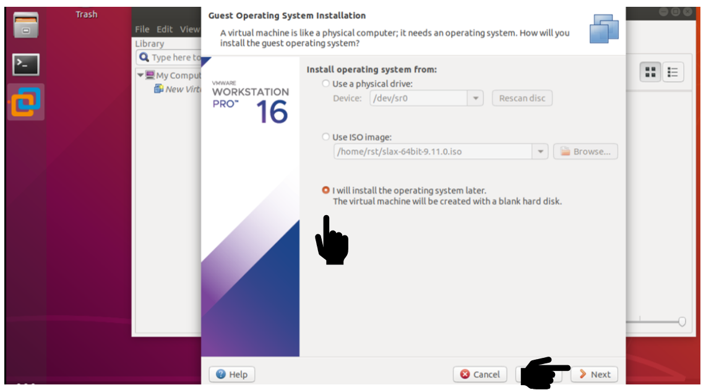

**Step 5: Select Linux Guest Operating system and Version Ubuntu to be installed on Virtual Machine**

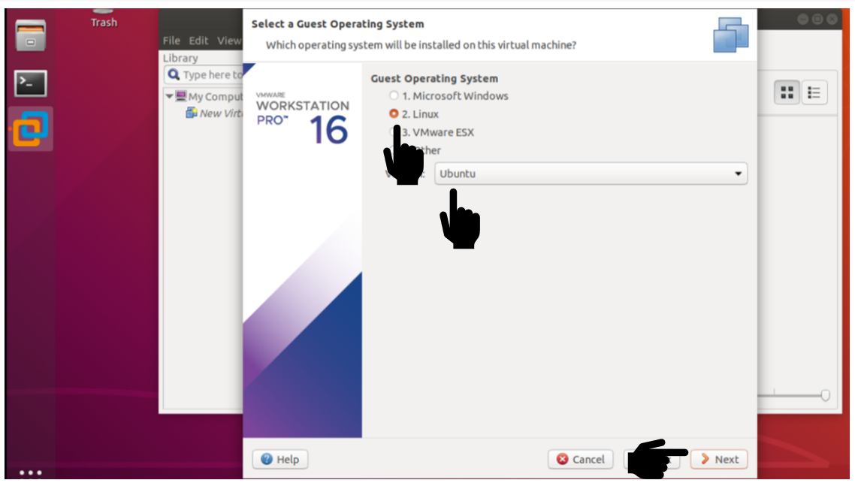

**Step 6: Provide a Virtual Machine Name and Location where this VM will be stored.**

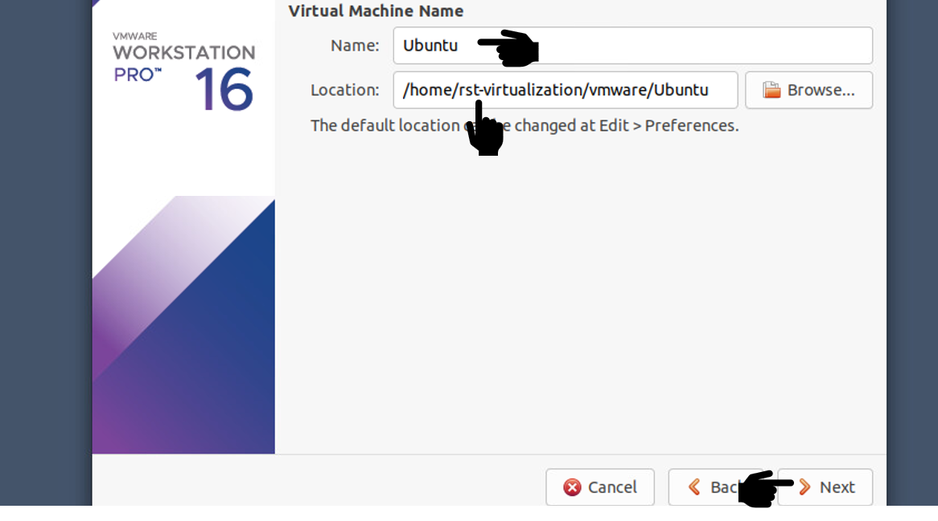

**Step 7: Being test environment We don’t need more than 3GB disk space for our VM, and select to store the VM on Single file.**

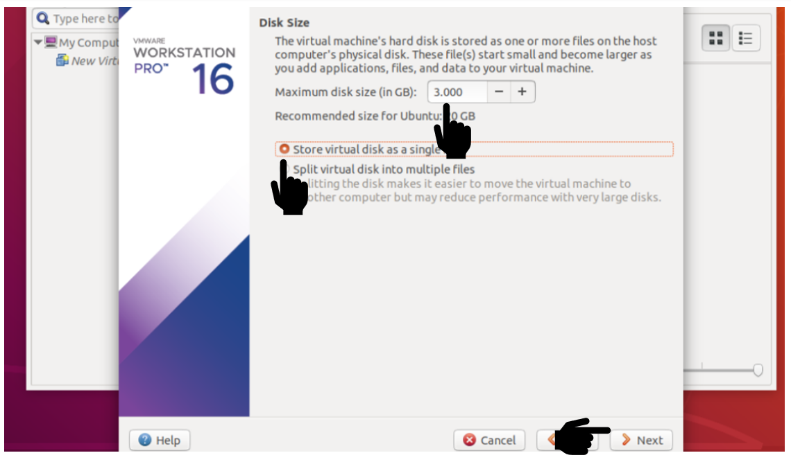

**Step 8: click customize Hardware**

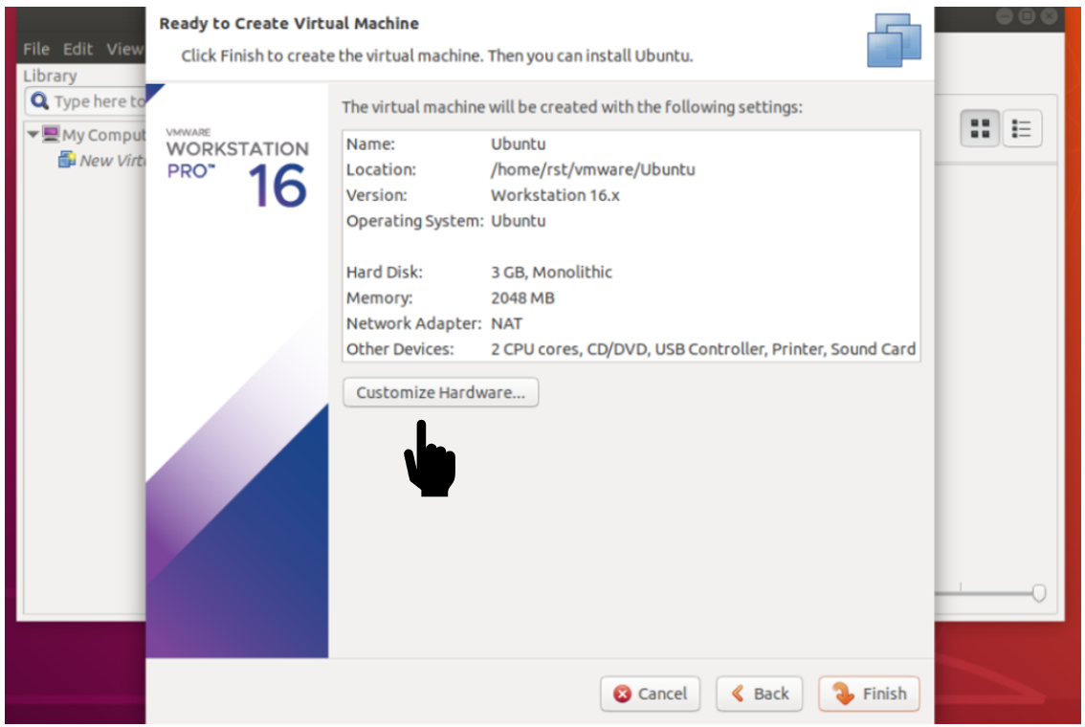This will open the following window

**Step 9: click New CD/DVD using file and then clock to browse the ISO Image to be loaded on VM**

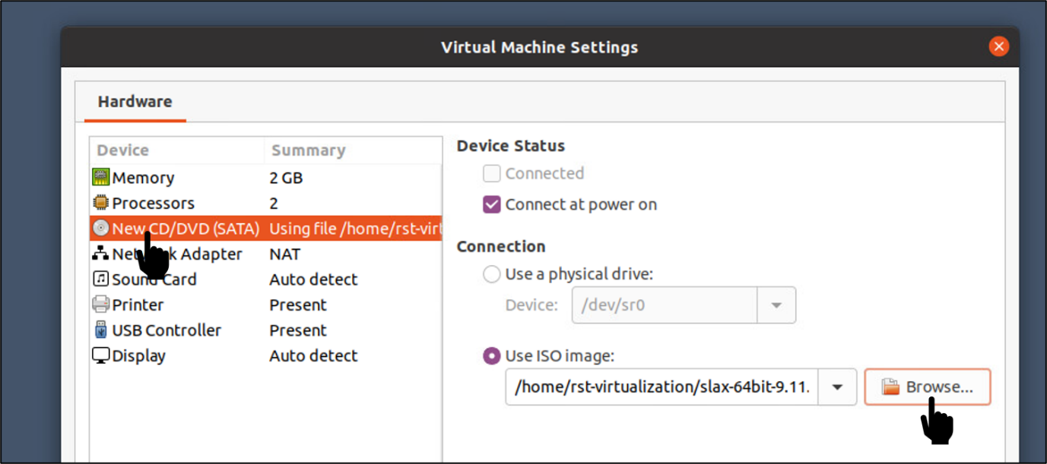This will open the following window

**Step 10: Go to Home and Double Click on the slax-64bit ISO image.**

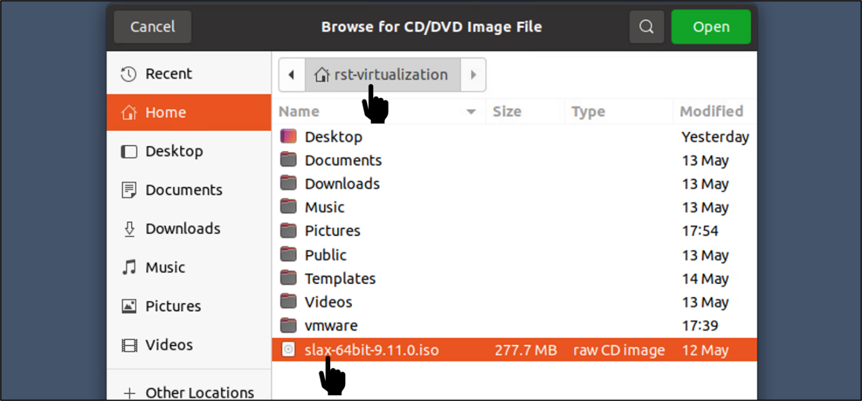

Following screen will be displayed, lets us save the selection

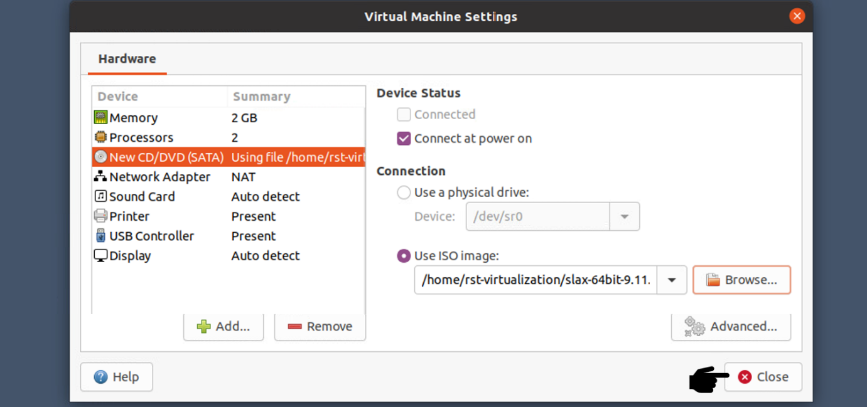

Click Finish

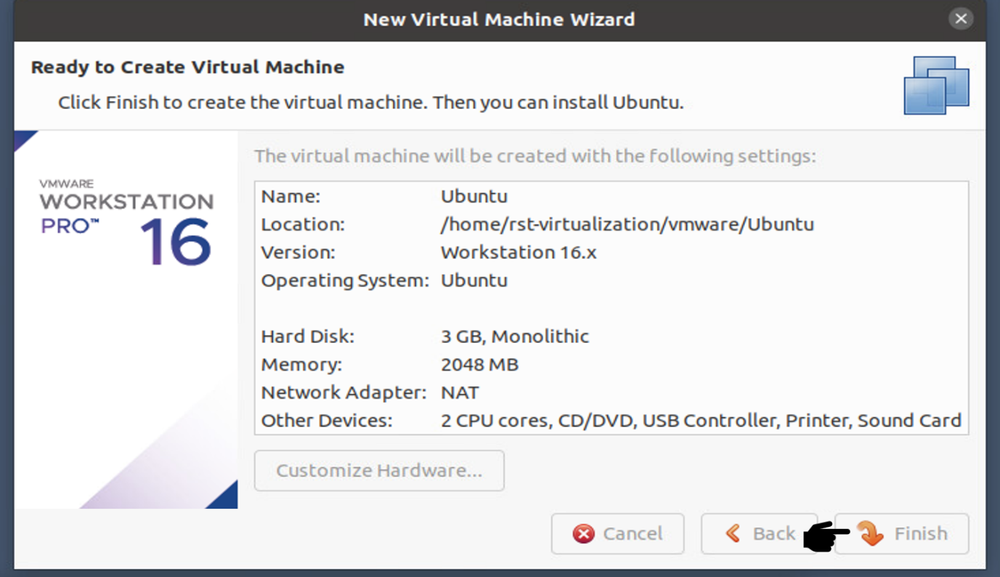

This will create the VM for you and following screen will be displayed.

We can now Power on our VM and test it.

**Step 11: Click to start the Guest Operating System**

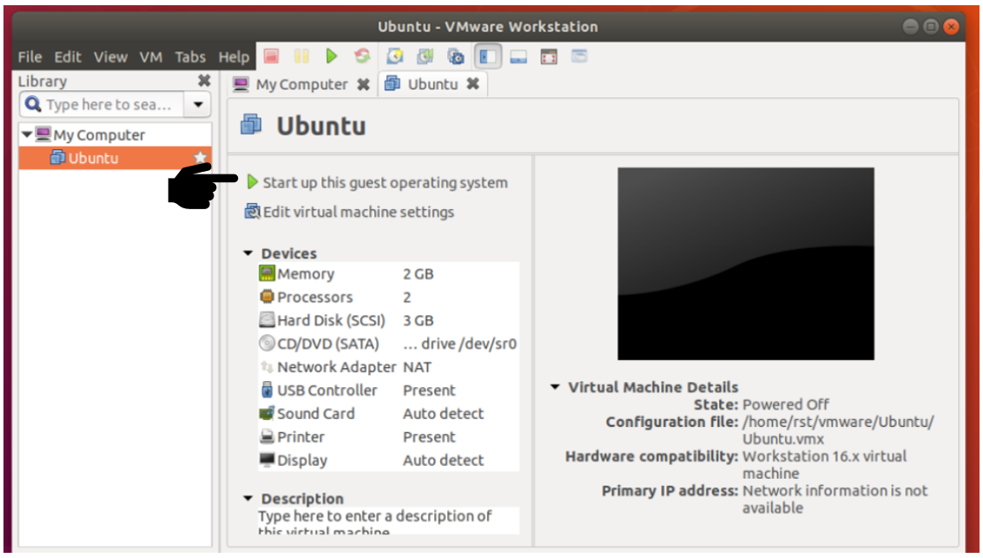

Virtual Machine will start the guest Operating System

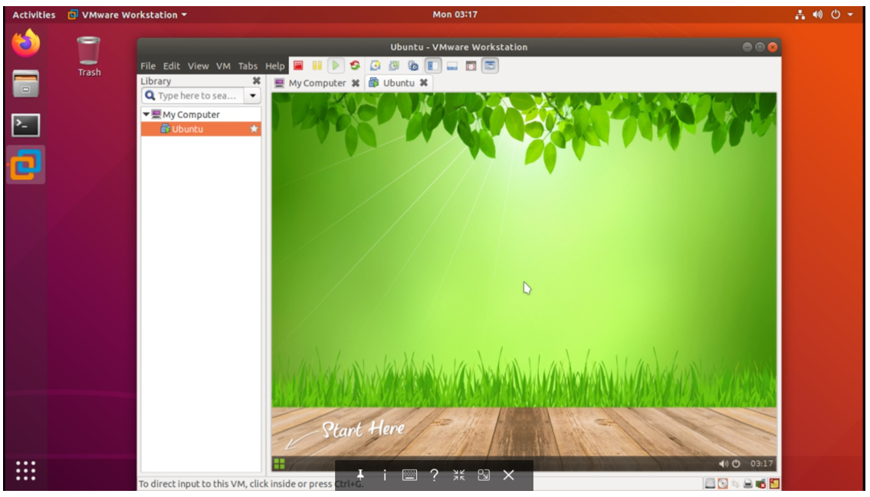

**Step 12: Stop and Delete the Virtual Machine that was just created.**

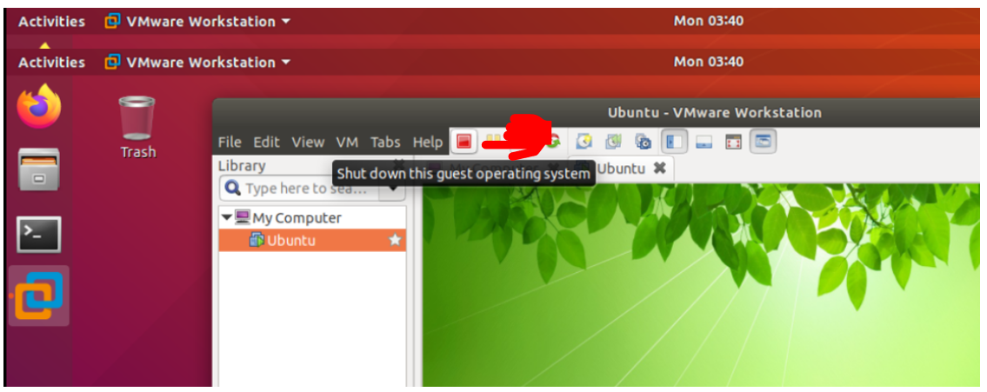

Following Screen will be displayed, now right click the Ubuntu machine and select manage and click device from disk

